
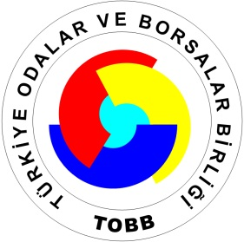

Business Matchmaking Summit between Turkish, EU and Egyptian operators in the Transport and Logistics sector
Mersin, 7-8 February 2013
Day 1 – 7.2.2013
08.30 Leave from Hotel to the conference venue Mersin Chamber of Commerce and Industry (MCCI)
09.00 Opening Session:
- Mr. Şerafettin Aşut, President of Mersin CCI
- Mr. Ahmed El Wakil, President of Federation of Egyptian Chambers
- Mr. Michele Villani, First Counsellor at the EU Delegation to Turkey, Head of the Trade, Economy and Agriculture Section
- H.E. Dr. Ismail Abdel Ghafar, chairman of the Arab Academy of the Arab league
- Mr. Faik YAVUZ, Deputy President of Board of Directors TOBB
- H.E. Mustafa SEVER, Republic of Turkey, Deputy Minister of Economy
10:15 Markets, business opportunities and financial support programs for business in Turkey and in Egypt
- Mr. Emir Murat Gül and Taylan Çoban (Experts from Ministry of Economy)
- Mr. Sevki ACUNER, EBRD Deputy Director General
- Mr. Akif Türkel, Transport expert at the EU Delegation to Turkey (on EU-funded projects)
- Dr. Alaa Ezz, FEDCOC Cairo (on market and business opportunities & projects in Egypt)
11:15 Coffee break

11:30 Introduction to the Transport and Logistics sector in Mersin and future projects
- Mr. Jozef ATAT (President of Mersin Logistics Platform)

12:00 Introduction to the Transport and Logistics sector in Egypt and future projects
- Prof. Dr. Khaled Hanafy, Dean of the College of International Transport and Logistics
- Chairmen of Egyptian Ports

12.30 Questions and Answers

12:45 Lunch Break at Tüccarlar Kulübü Restaurant Mersin

14.00-18.30 Individual B2B Meetings between EU, Turkish and Egyptian companies at the MCCI

19.30 Dinner at Aşina Restaurant
21.00 Overnight stay in Mersin

Day 2 – 8.2.2013
Follow up of B2B talks and, in parallel, group visit to project sites in greater Mersin

09.30-12:00: Continuation of B2B talks for companies interested

09.30 Site visit to the Mersin International Port: Introduction and presentation
11.30 Site visit to the Mersin Free Trade Zone: Introduction and presentation
13.00 Lunch Break at Göçtü Restaurant Mersin

